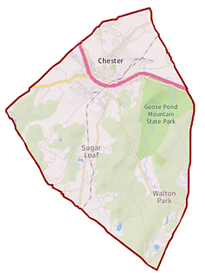
Town of Chester
Zoning Board of Appeals

1786 Kings Highway
Chester, NY 10918
(845) 469-7000 x338

Chairman: Gregg Feigelson

Members: Julie Bell
Dan Doellinger
Bob Favara
Walter Popailo
Alternate: Tom Atkin

Attorney: Robert Dickover
Secretary: Julie Tiller

Agenda
Jan. 14, 2021 |  | 7:00 PM |  | Location: Zoom Teleconference  Information below
Time | Item
7:00 PM | Pledge of allegiance
 | Adoption of minutes |  | (as applicable)
 | Other business |  | (as applicable)
 | Item |  | Applicant / Address / Zone |  |  | Summary
 | Public Hearing |  | Yogesh & Aradhna Pal  15 Davis Hill Rd  S/B/L 7-1-51 AR3 Zone |  |  | Area variance
 | Public Hearing |  | Daniel & Julia Doellinger  20 Twin Brooks Drive  S/B/L 24-2-11.2 AR3 Zone |  |  | Area Variance
Join Zoom Meeting  https://us02web.zoom.us/j/84902221722  Meeting ID: 849 0222 1722  Passcode: 300152  One tap mobile  +19294362866,,84902221722#,,,,,,0#,,300152# US (New York)  +13017158592,,84902221722#,,,,,,0#,,300152# US (Washington D.C) |  |  |  |  | Dial by your location  +1 929 436 2866 US (New York)  +1 301 715 8592 US (Washington D.C)  +1 312 626 6799 US (Chicago)  +1 253 215 8782 US (Tacoma)  +1 346 248 7799 US (Houston)  +1 669 900 6833 US (San Jose)  Meeting ID: 849 0222 1722  Passcode: 300152  Find your local number: https://us02web.zoom.us/u/kd8b6DBZRg

